**FINAL PROJECT DOCUMENTATION**

**Retail Store Microservices Project**

**Infrastructure Setup**

* Provision Infrastructure
* Create VPC
* Enable DNS Support for VPC (important for EKS & RDS)
* Create Two Public Subnets
* Create 2 Private Subnets
* Create Internet Gateway & Attach to VPC
* Attach IGW
* Allocate Elastic IP
* Create NAT Gateway in Public Subnet 1
* Create Route Tables
* Associate with Public Subnets
* Add Route to Internet
* Private Route Table
* Private Route Table
* Add NAT Gateway route
* Create EKS Cluster
* Create a DB Subnet Group
* Create RDS (MySQL) for catalog Service
* Create DynamoDB Table for cart Service

**Architecture Diagram**

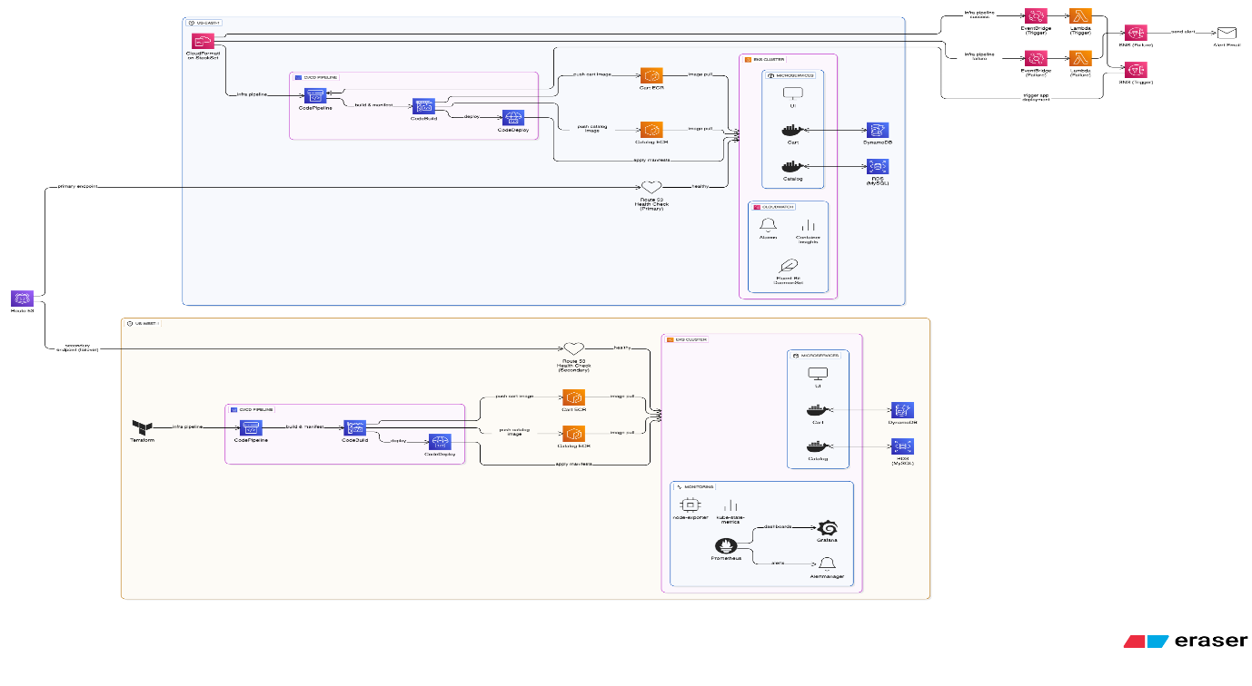

**PIPELINES**

I have built the infrastructure using CodePipeline with a CloudFormation StackSet in the us-east-1 region.

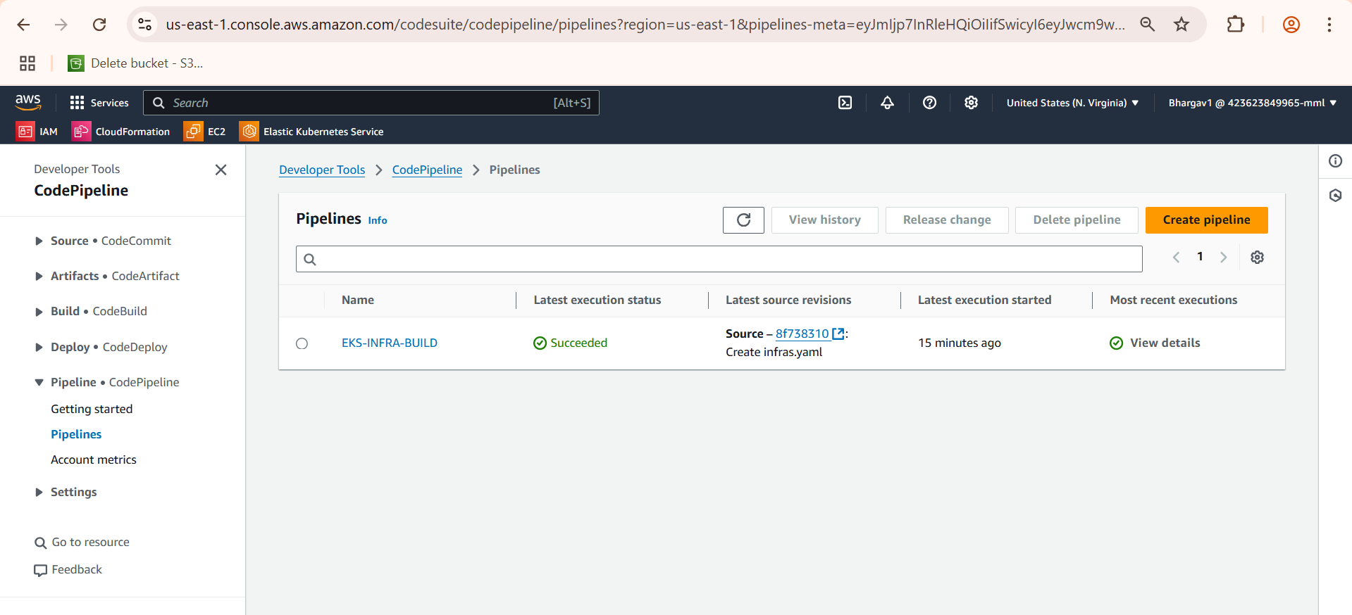

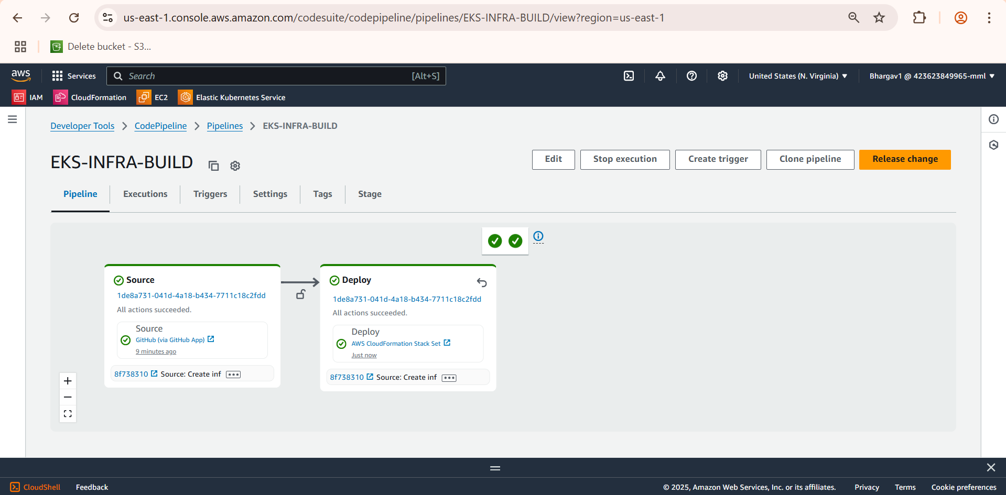

After pipeline is Successful I went to CloudFormation Stack-Set to verify the status of Infrastructure Creation

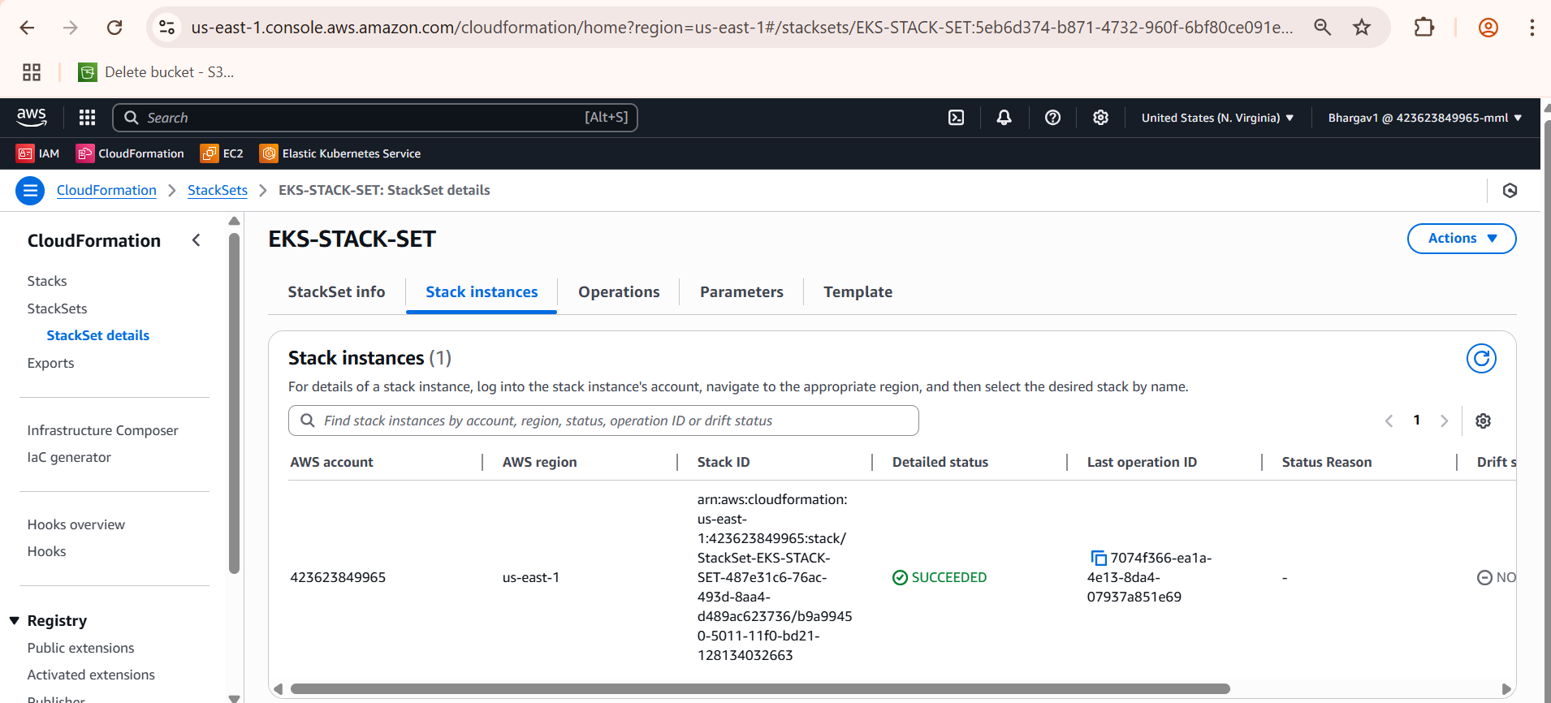

Then I have created Elastic Container Registry(ECR)

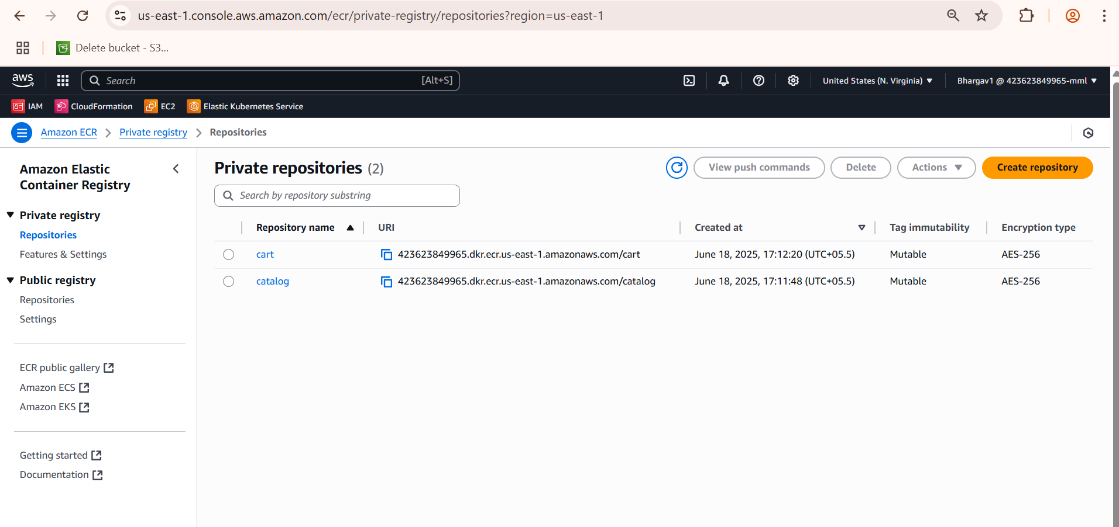

CodeBuild for the Deployment

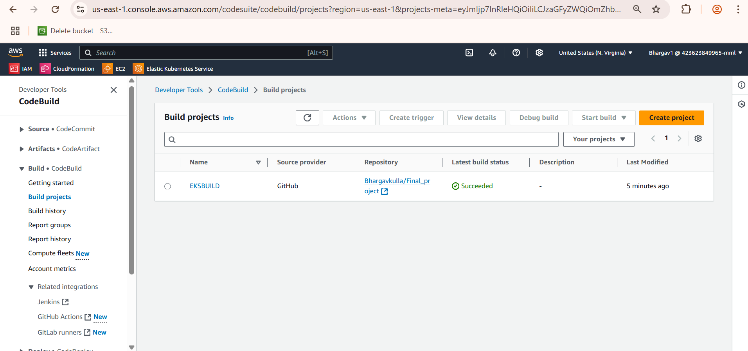

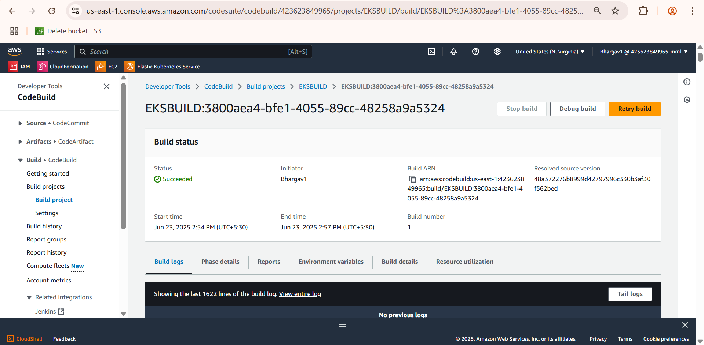

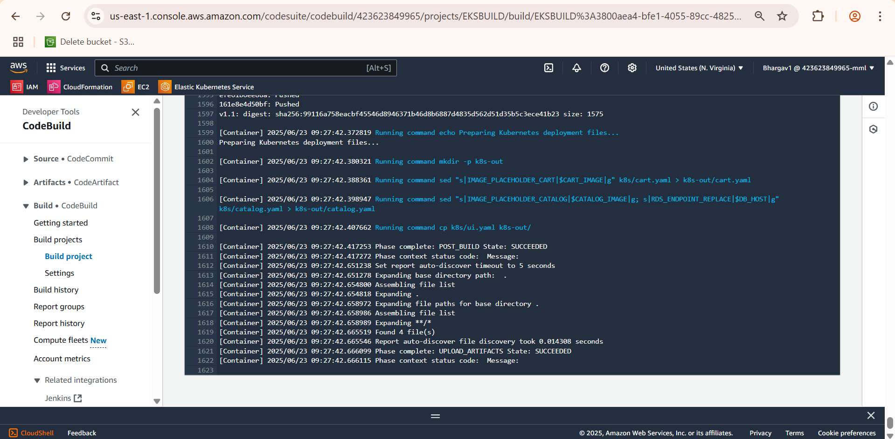

So I have created two Pipelines one for building the Infrastructure and One for Deploying application

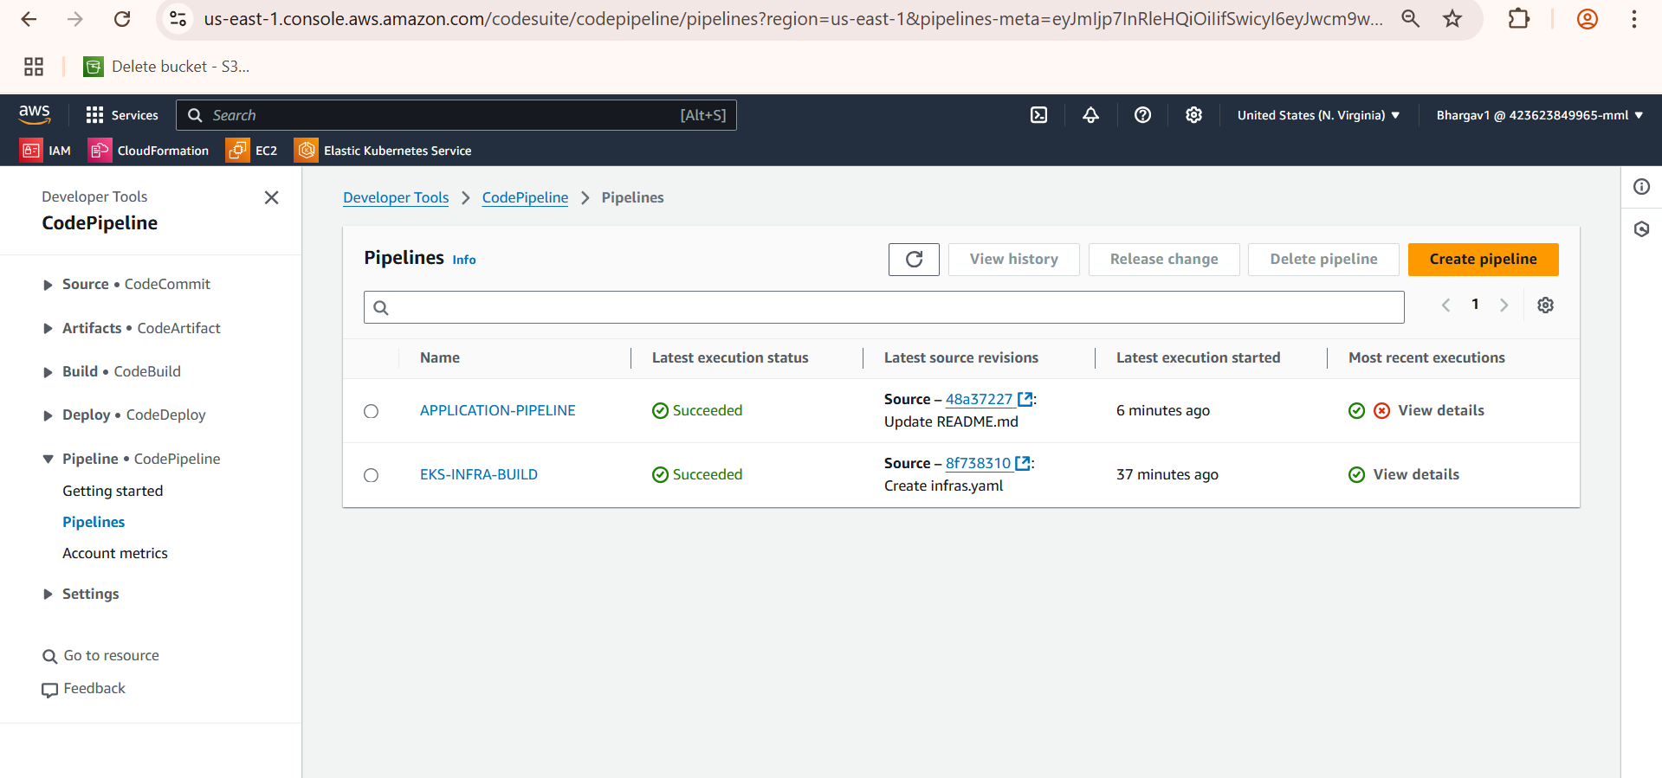

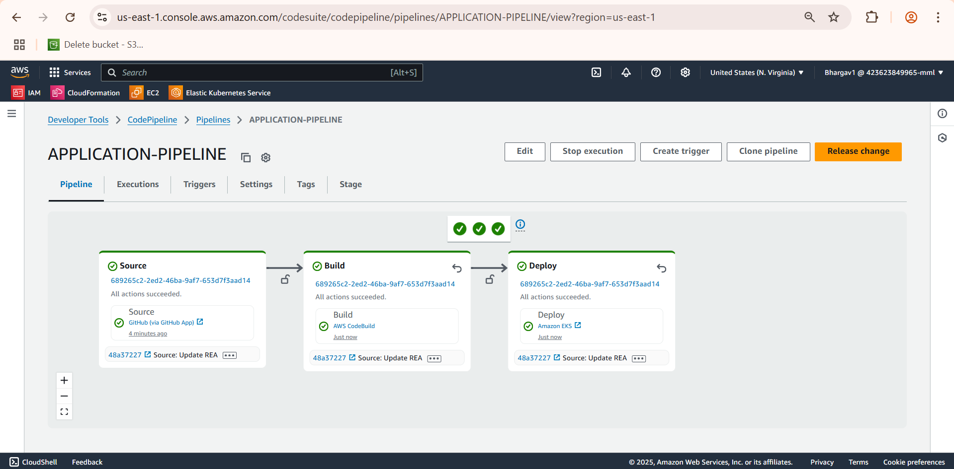

**SonarQube**

We use SonarQube here to automatically review and measure code quality and security

* Code quality is good
* There are no bugs, security issues, or duplication
* The Quality Gate has passed

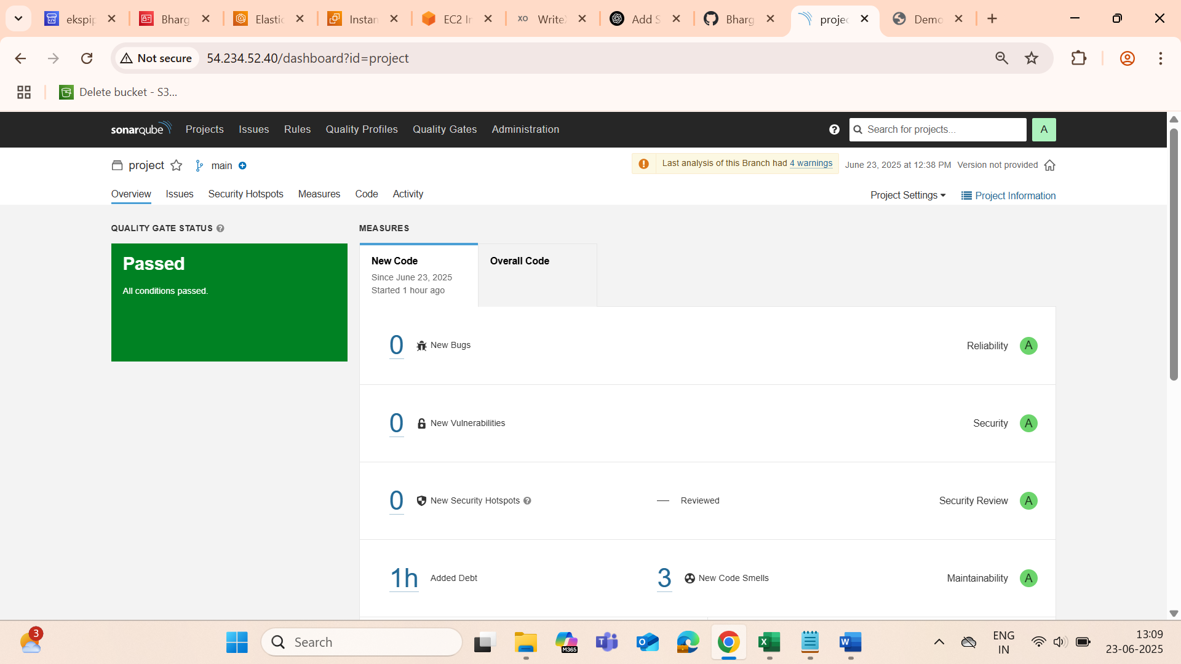

Next we will check whether our all pods are running or not and we check the service for the front-end load balancer URL.

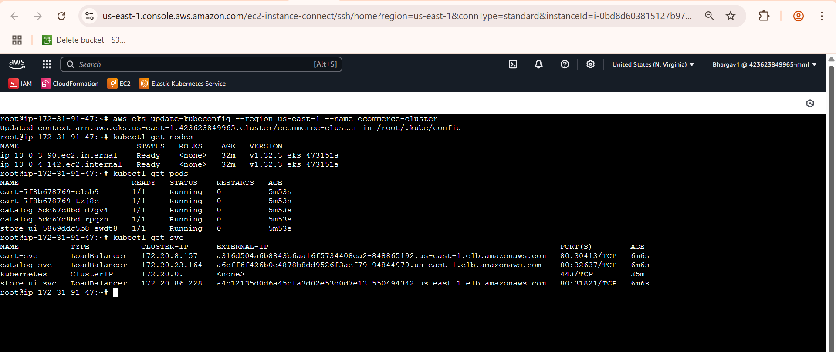

**Pipeline Trigger Using Lambda, SNS and EventBridge**

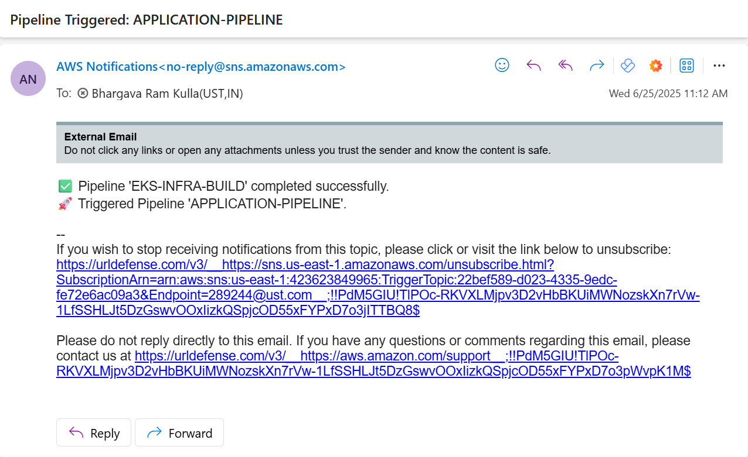

**Route53**

* Bought a domain bhargavkulla.com
* Set up a Route 53 health check to monitor the health of the primary endpoint
* Configured DNS Record with Failover Routing
* Then accessed the website with the domain name bhargavkulla.com

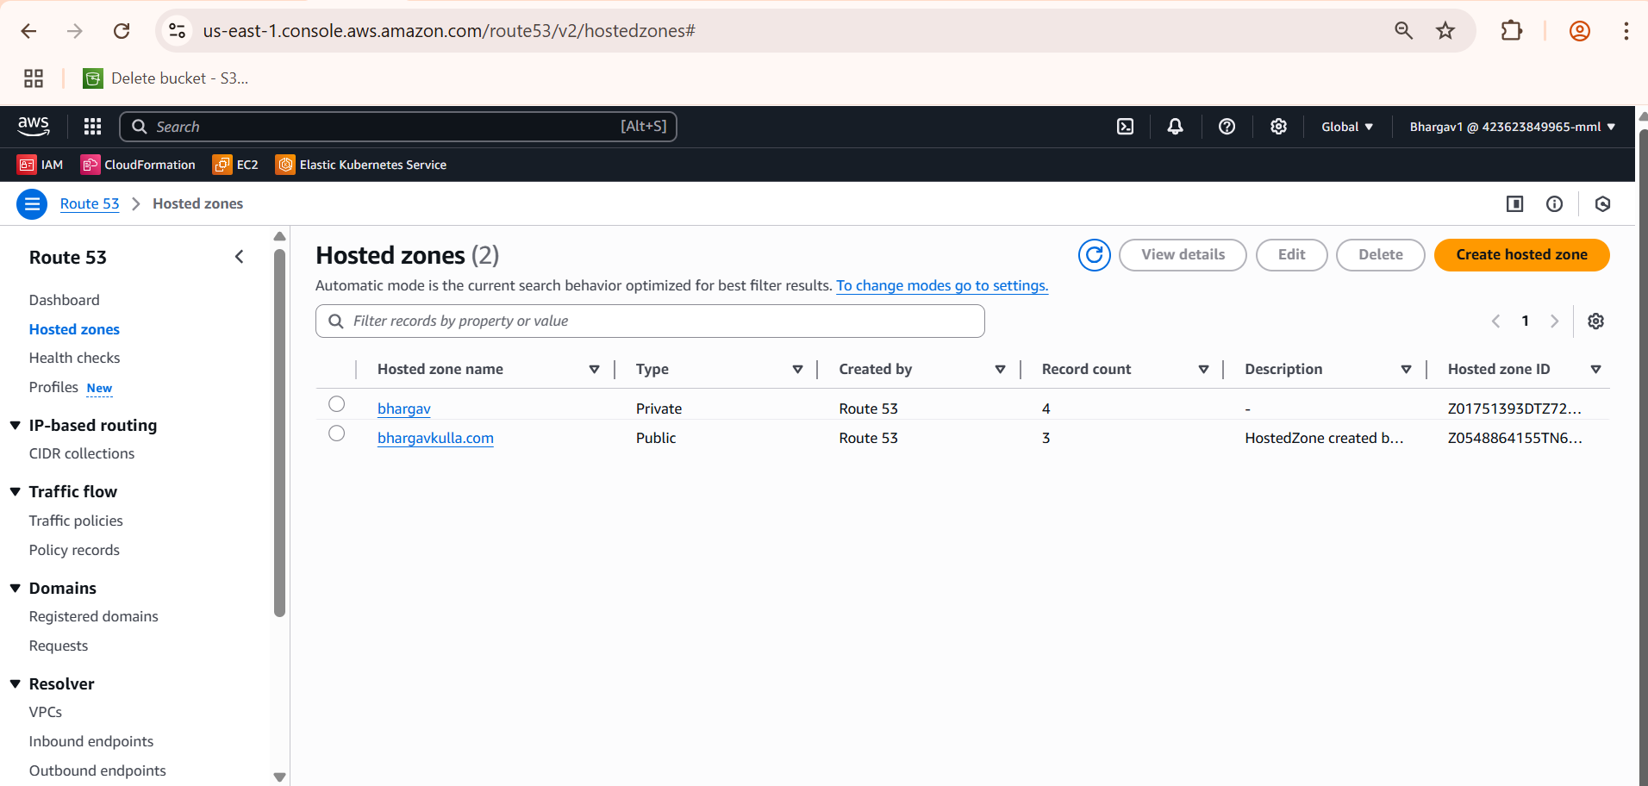

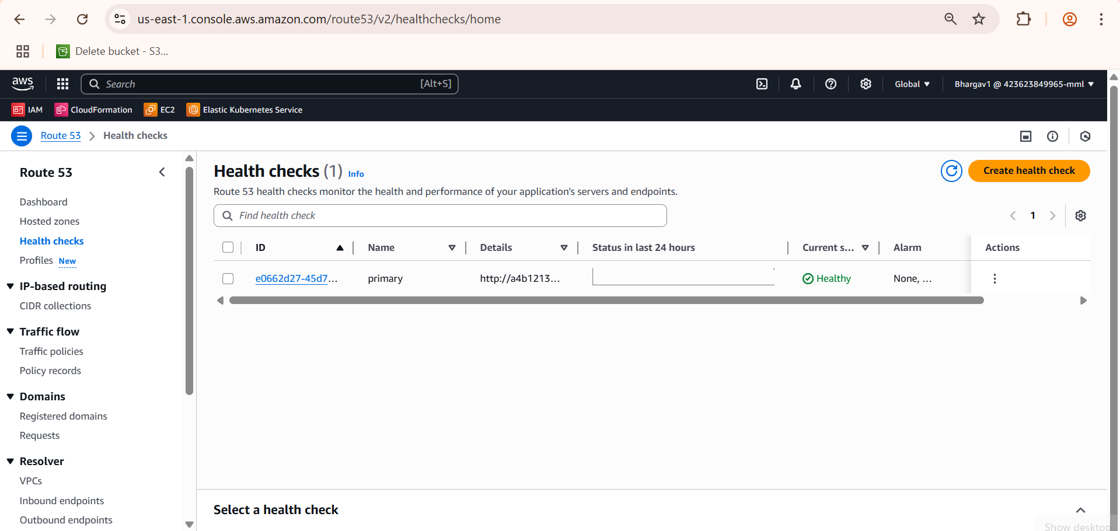



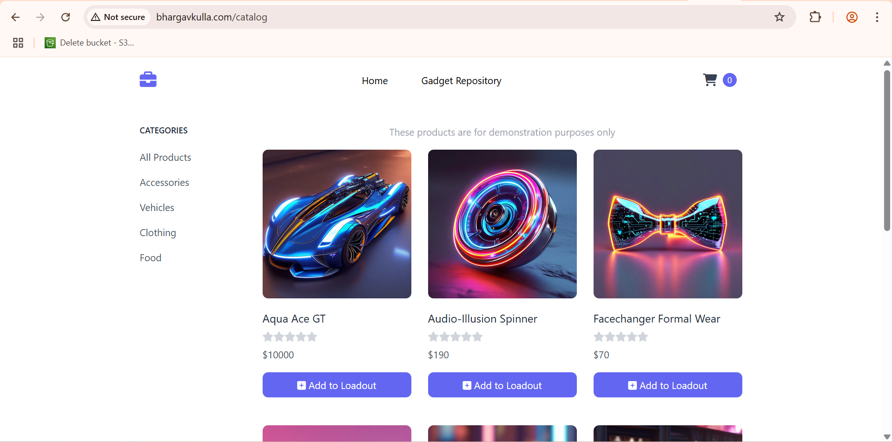

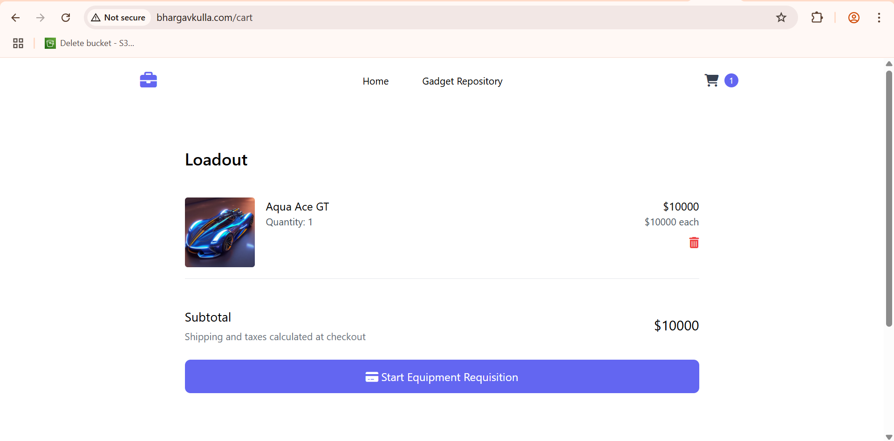

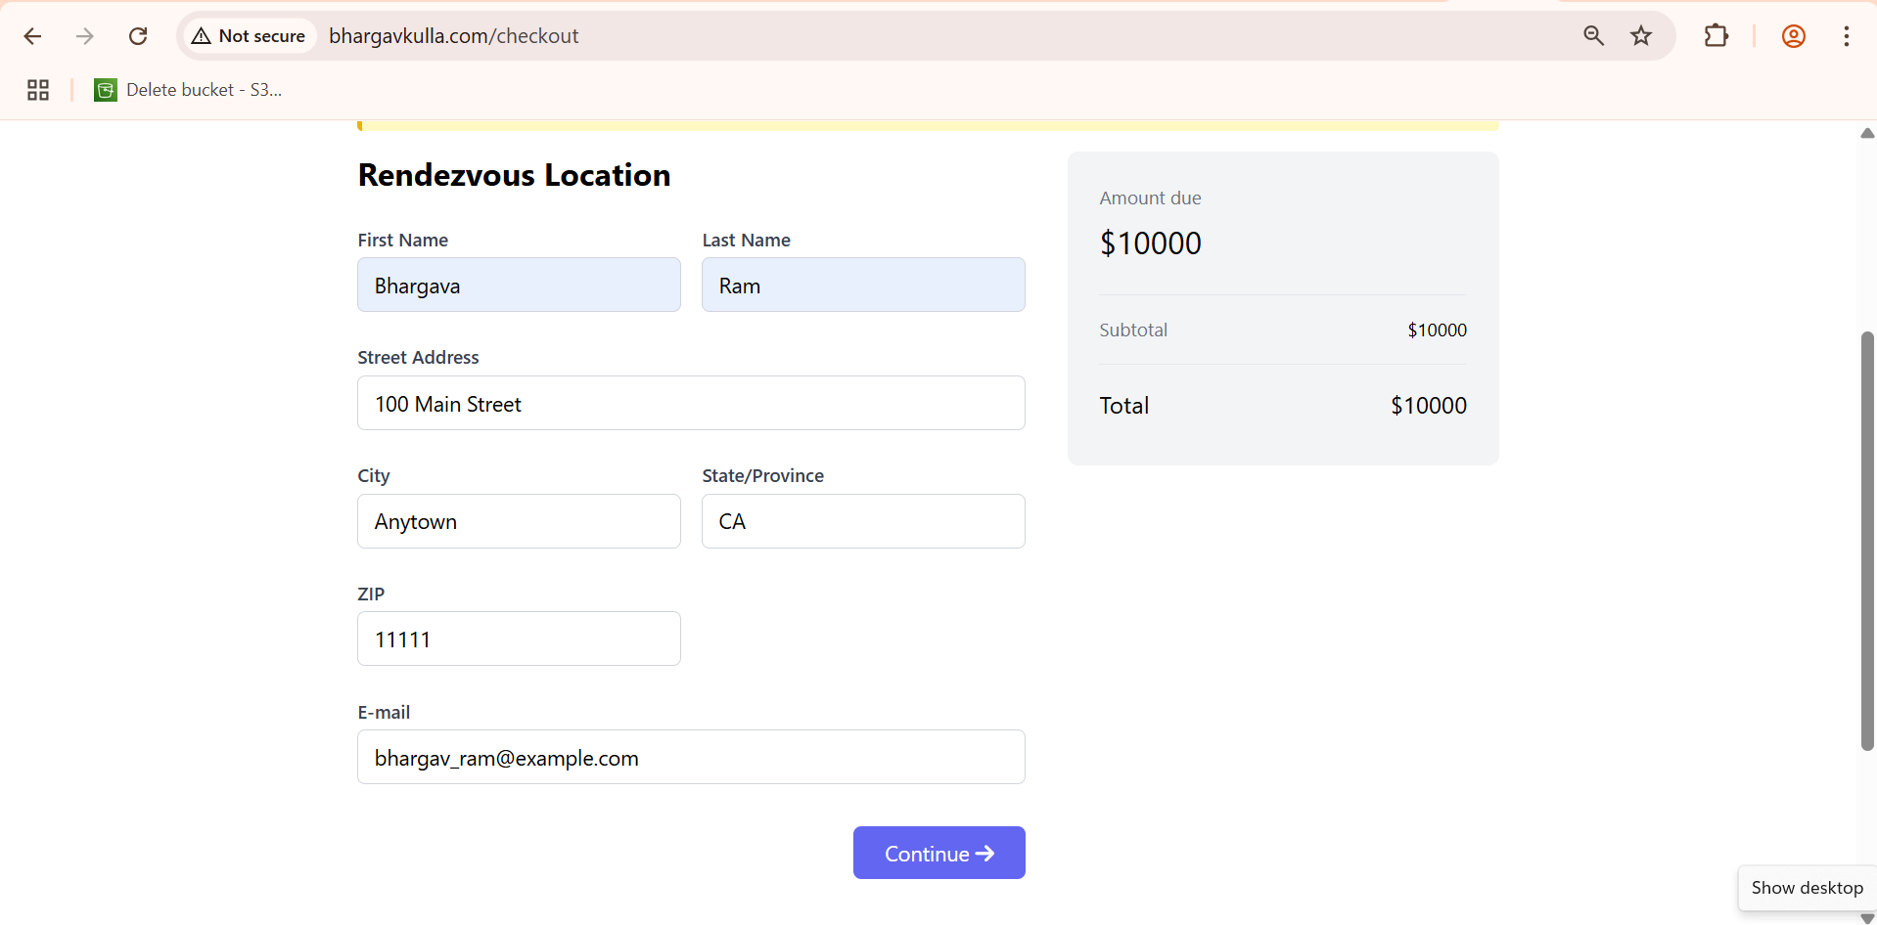

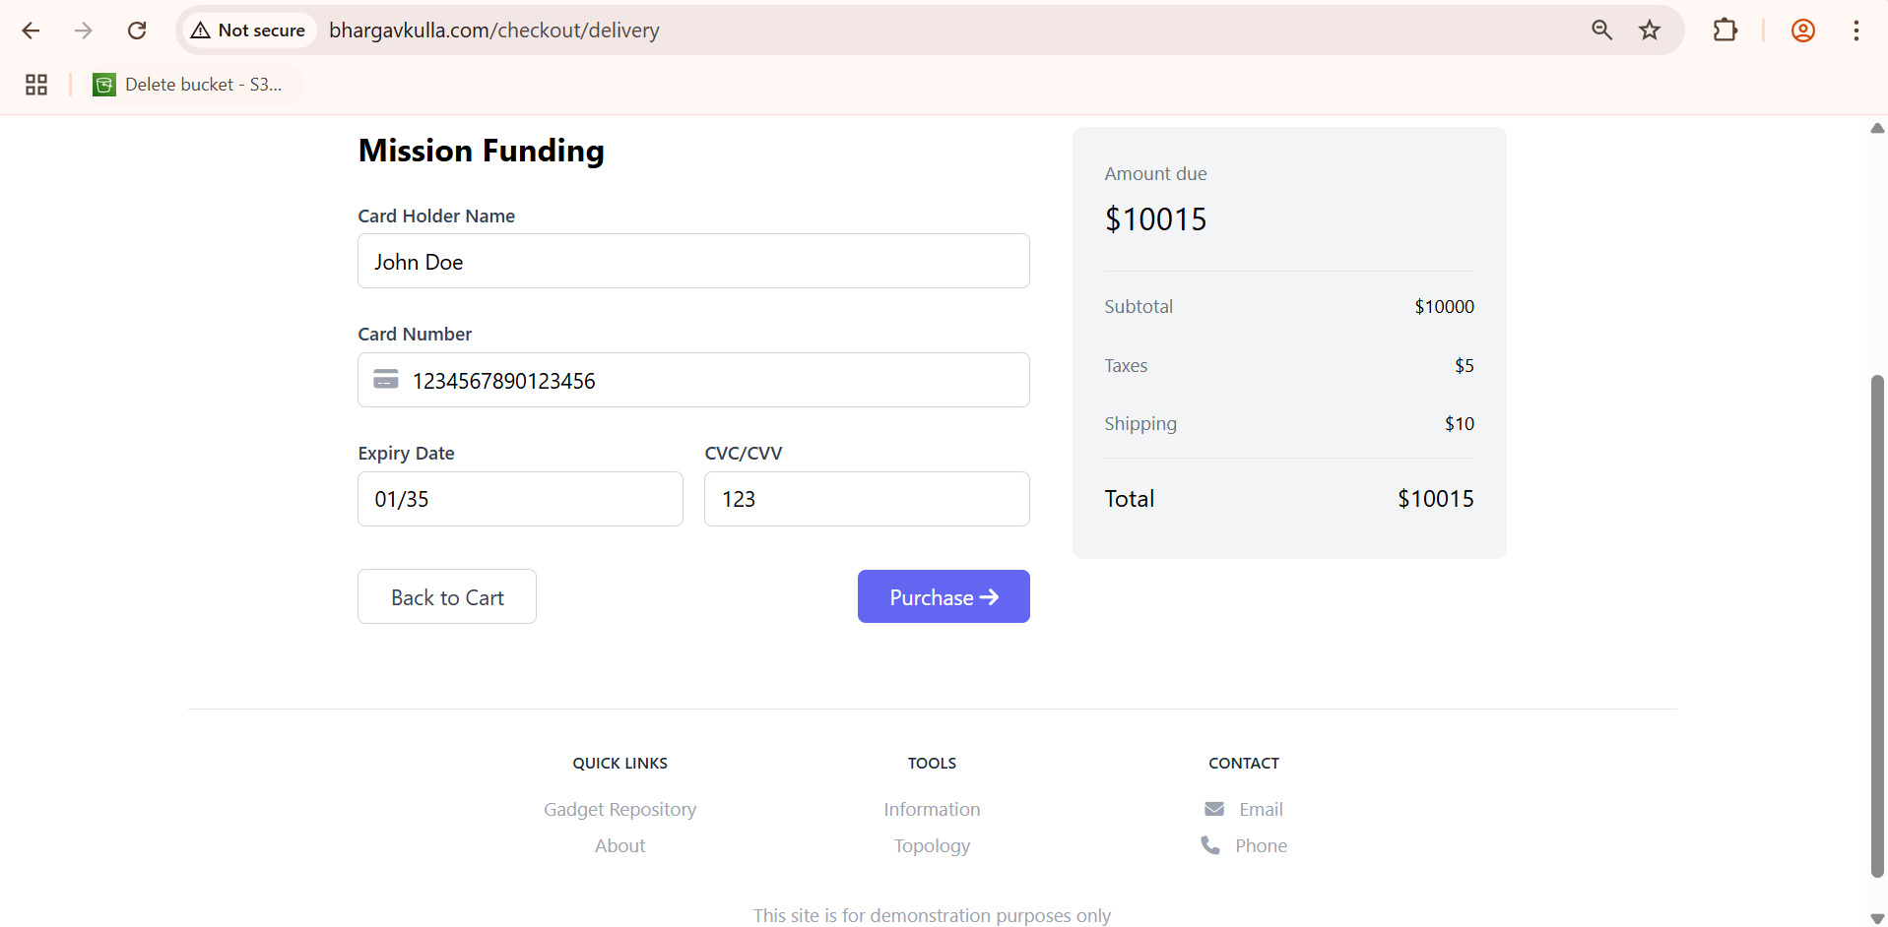

**CloudWatch**

Monitoring and alerting for EKS was implemented using Fluent Bit, CloudWatch Container Insights, and SNS email alerts. CloudWatch alarms were configured to notify on high CPU usage with email integration.

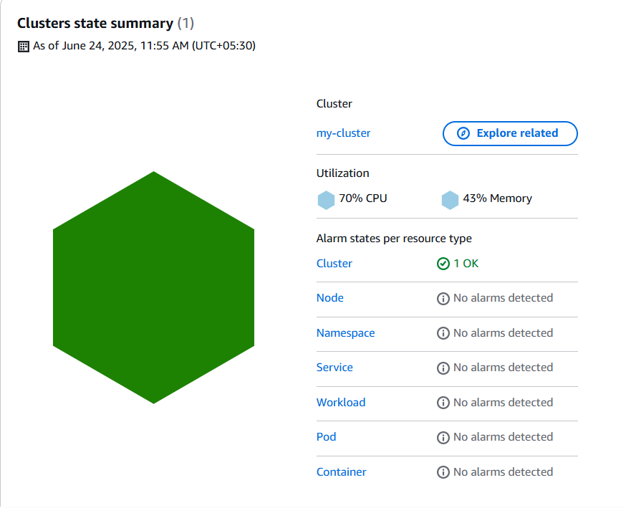

Fluent Bit is deployed as a DaemonSet to collect logs from all nodes and send them to CloudWatch Logs.

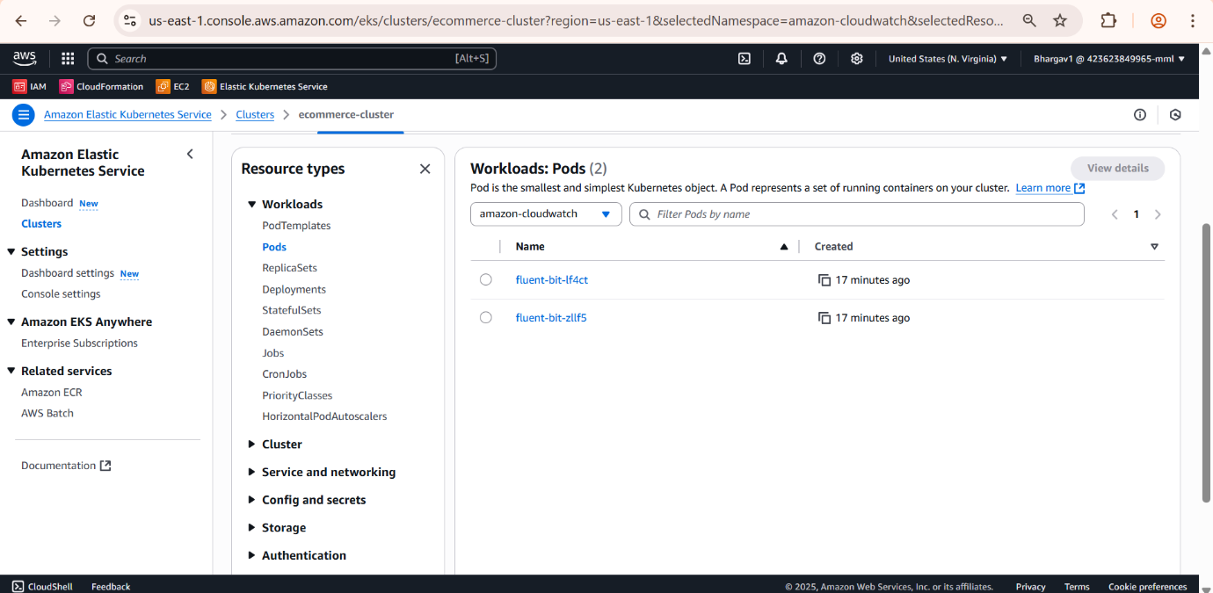

Logs are automatically grouped by namespace:

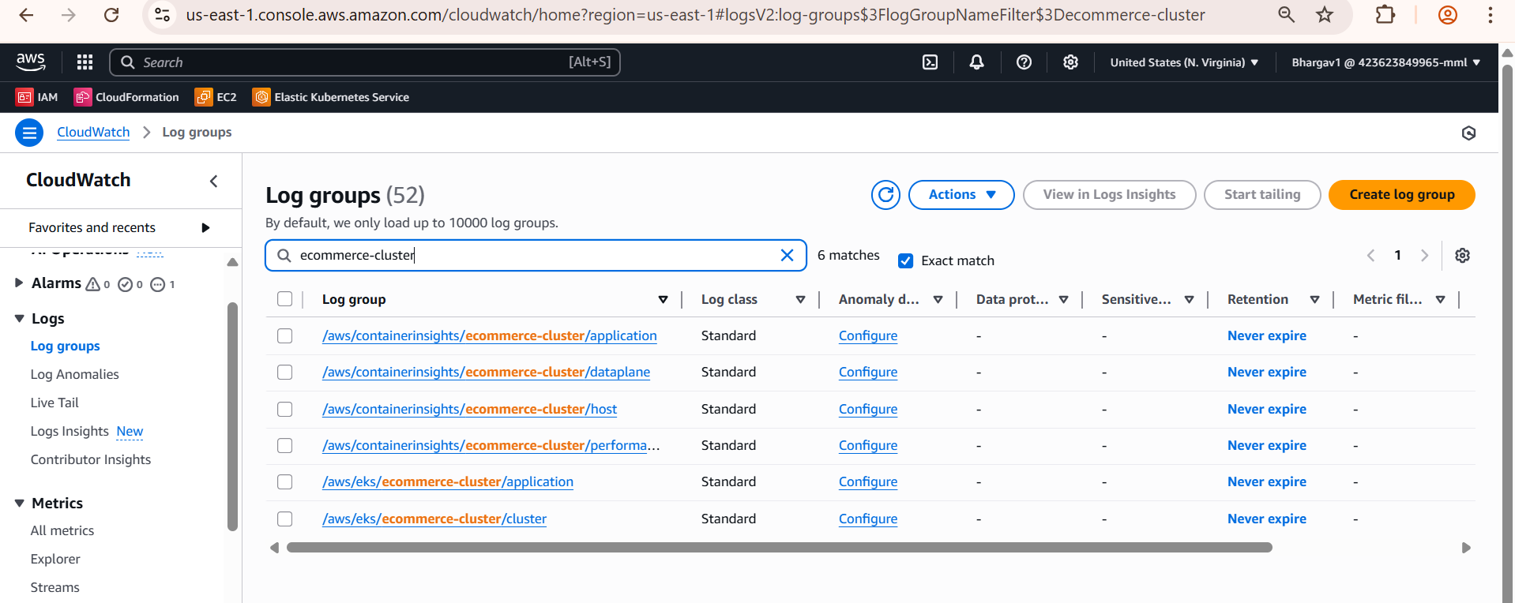

Metrics like CPU, memory, and pod availability are visualized using Container Insights.

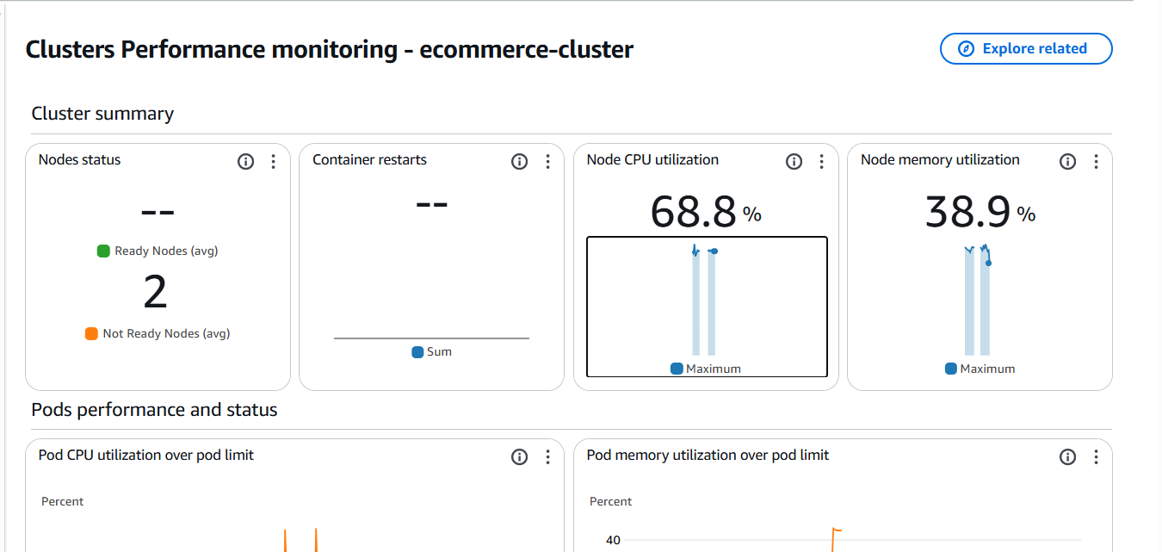

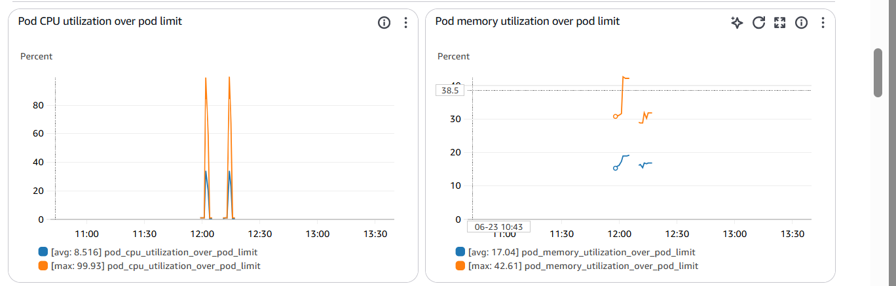

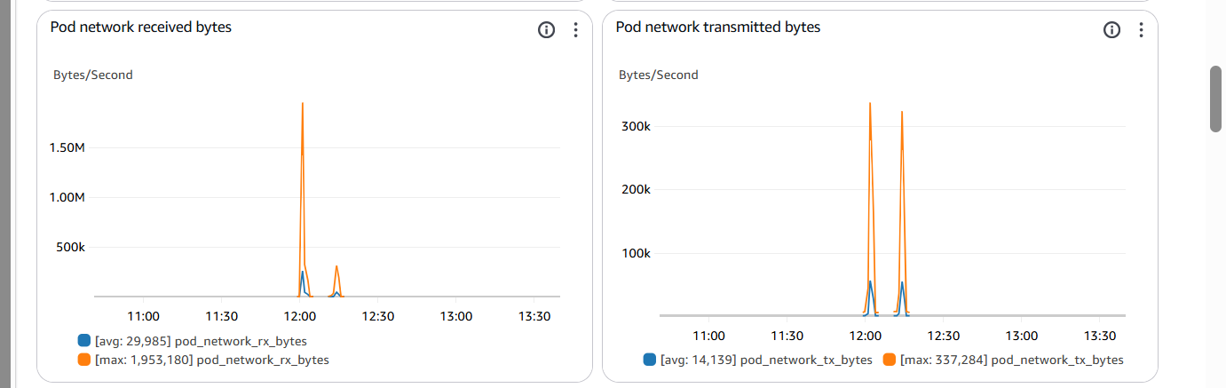

An SNS topic like eks-alerts was created to receive CloudWatch alarm notifications via email.

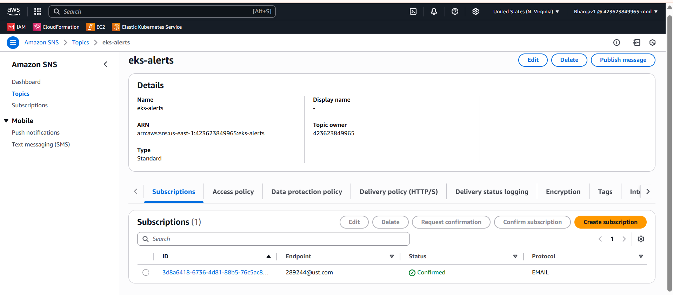

CloudWatch alarm is set to monitor CPU usage over 80% for two periods.

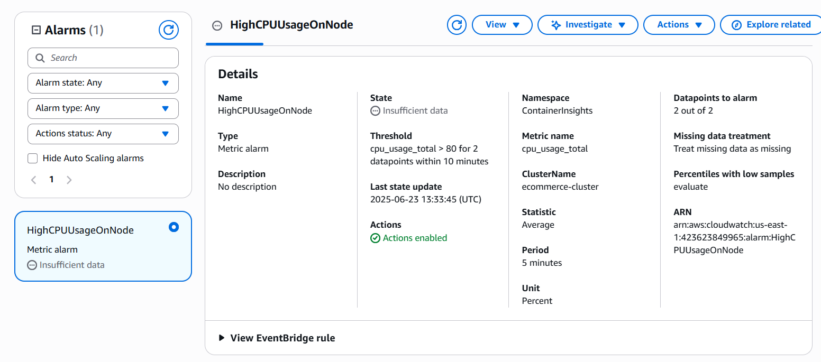

This alarm detects if any pod in the cluster restarts more than once in a 5-minute window, triggering an alert for investigation.

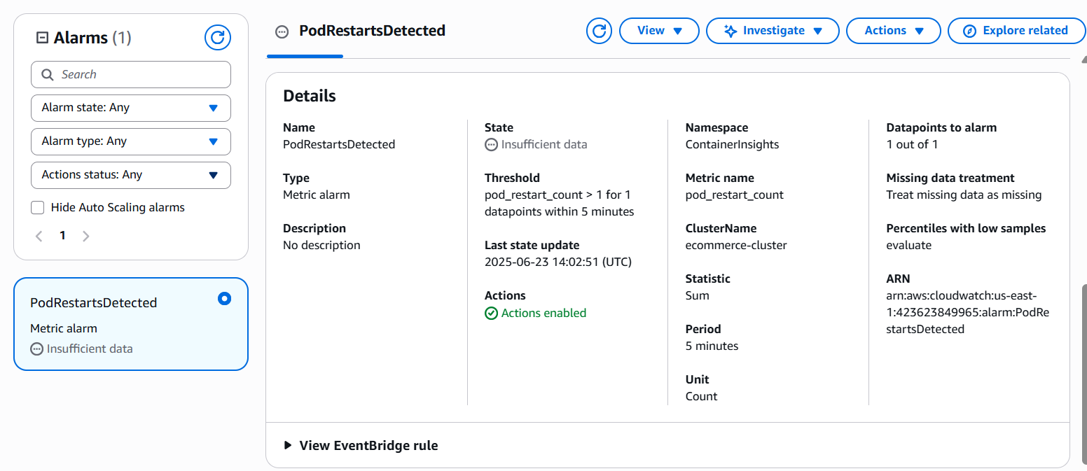

A CloudWatch alarm named HighMemoryUsageOnNode was configured to monitor memory usage of the EKS cluster. If memory exceeds 30% for two consecutive 5-minute periods, an email alert is triggered via the eks-alerts SNS topic.

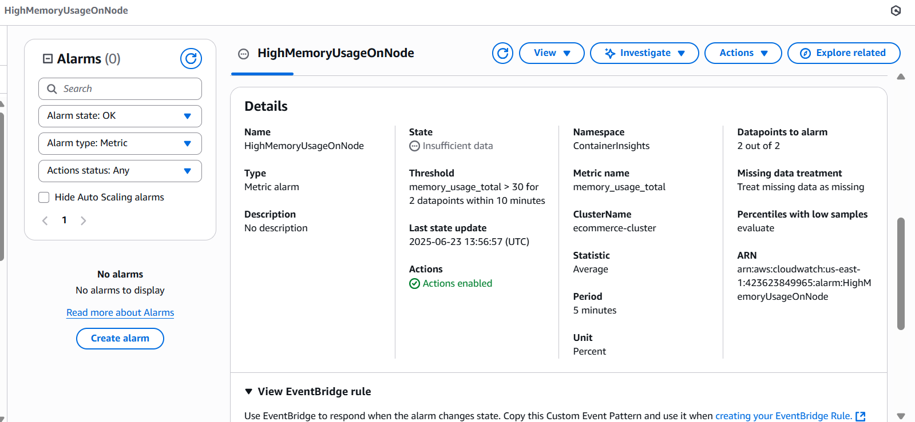

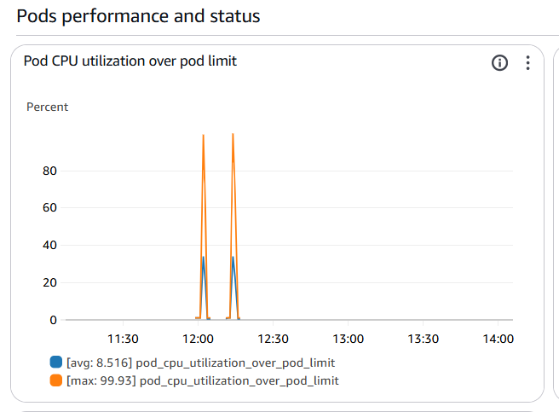

Testing for Alert Message

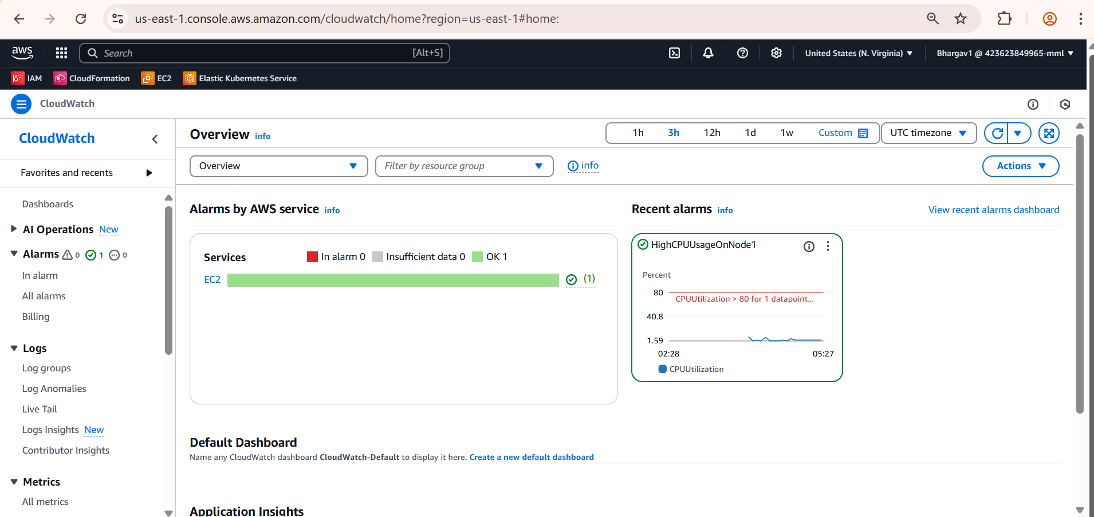

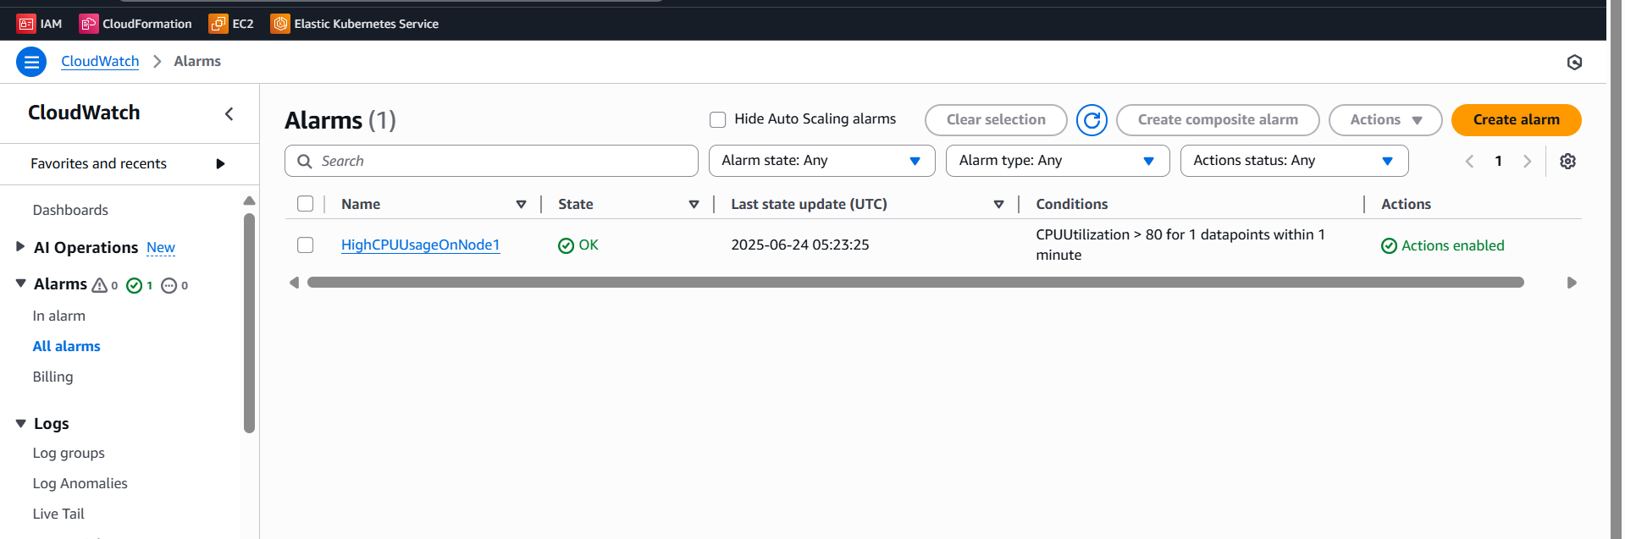

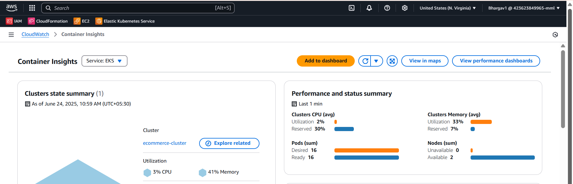

Here I Got Alert Message to my mail

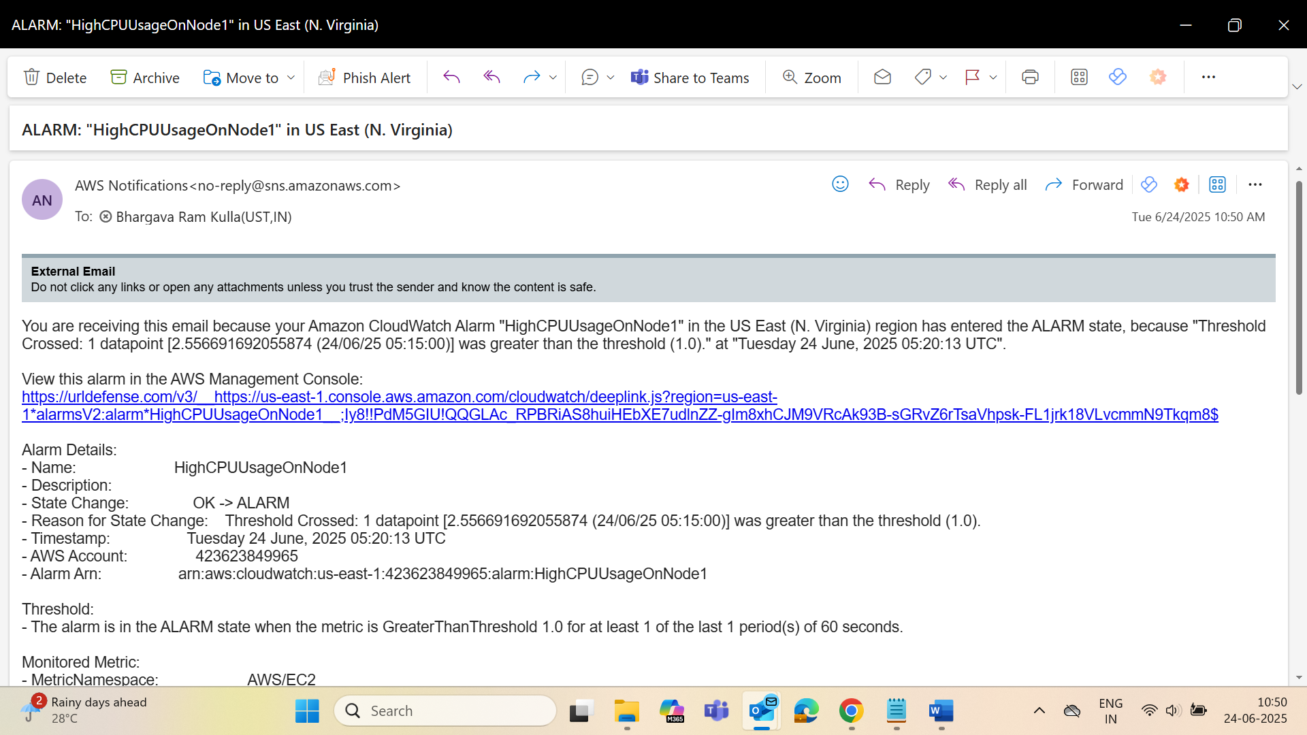

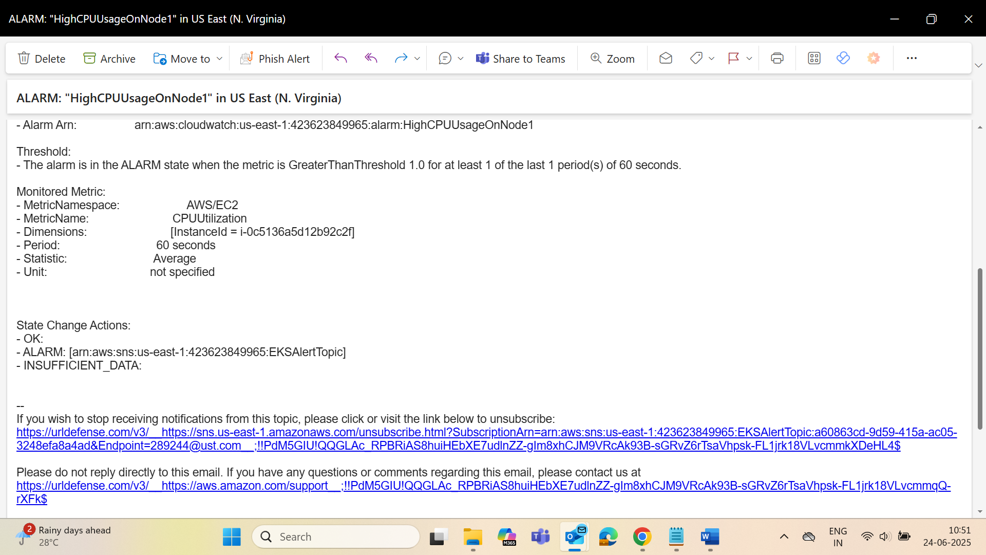

**If Pipeline Fails?**

* We will get mail that Pipeline Failed
* We will do this using Event Bridge
* For that First we should create Topic then add subscription
* Then Create Lamba
* Then Go to Event Bride and select CodePipeline(Failure)

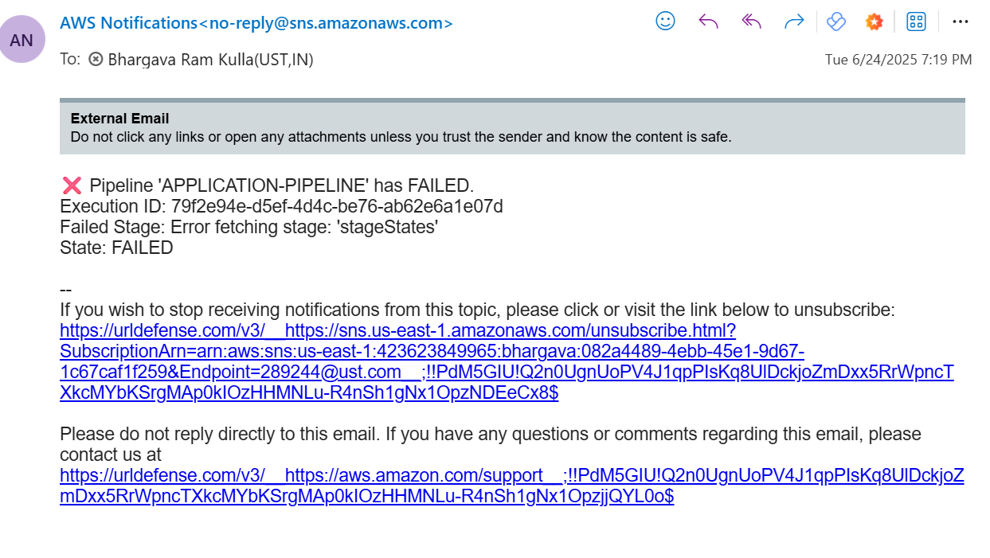

REGION 2 (us-west-1)  
Pipeline

Now in another region building infrastructure using terraform by using CodeBuild By taking source from CodeCommit  
CodeCommit Repoisitory

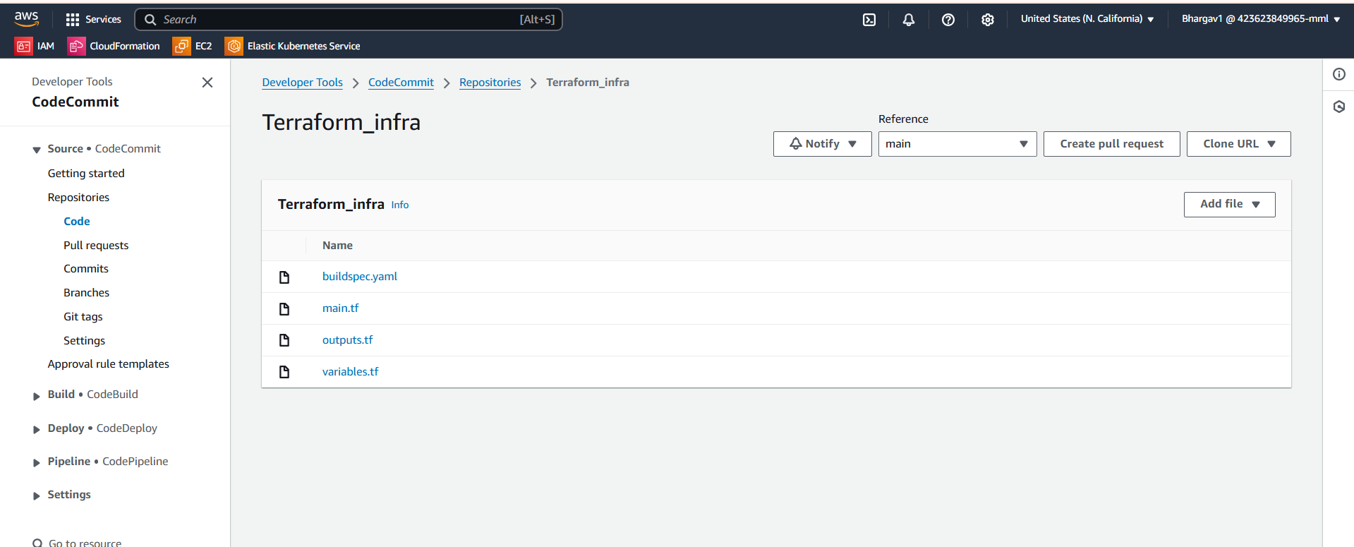

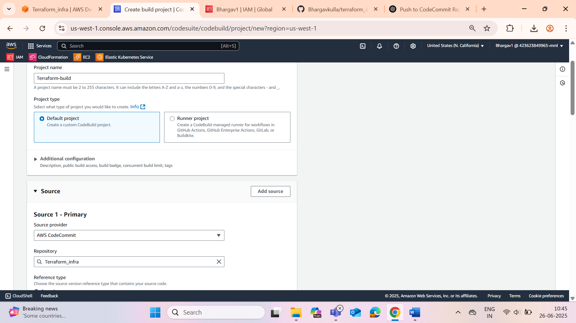

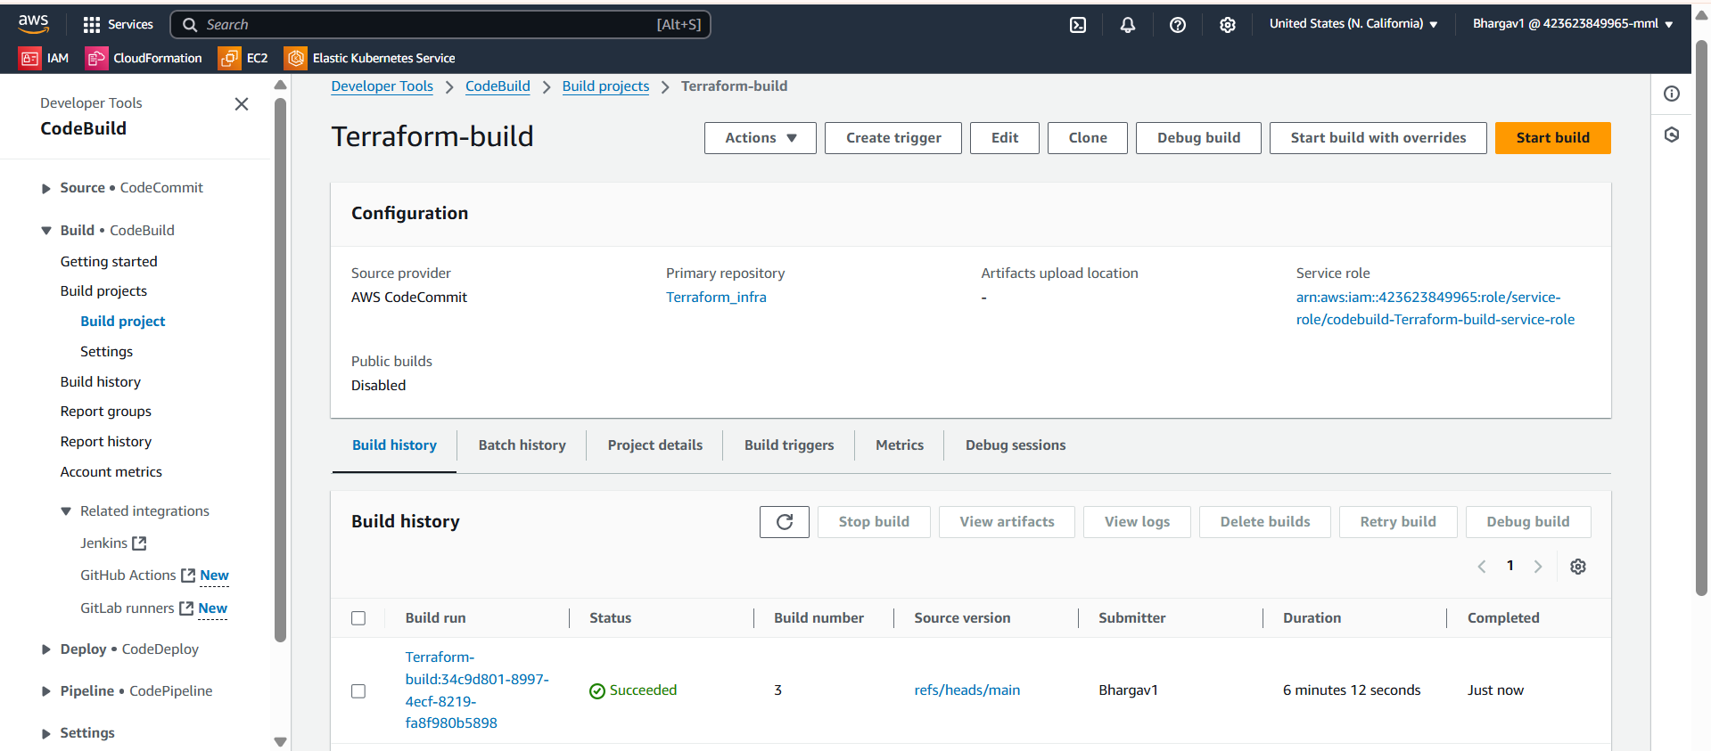

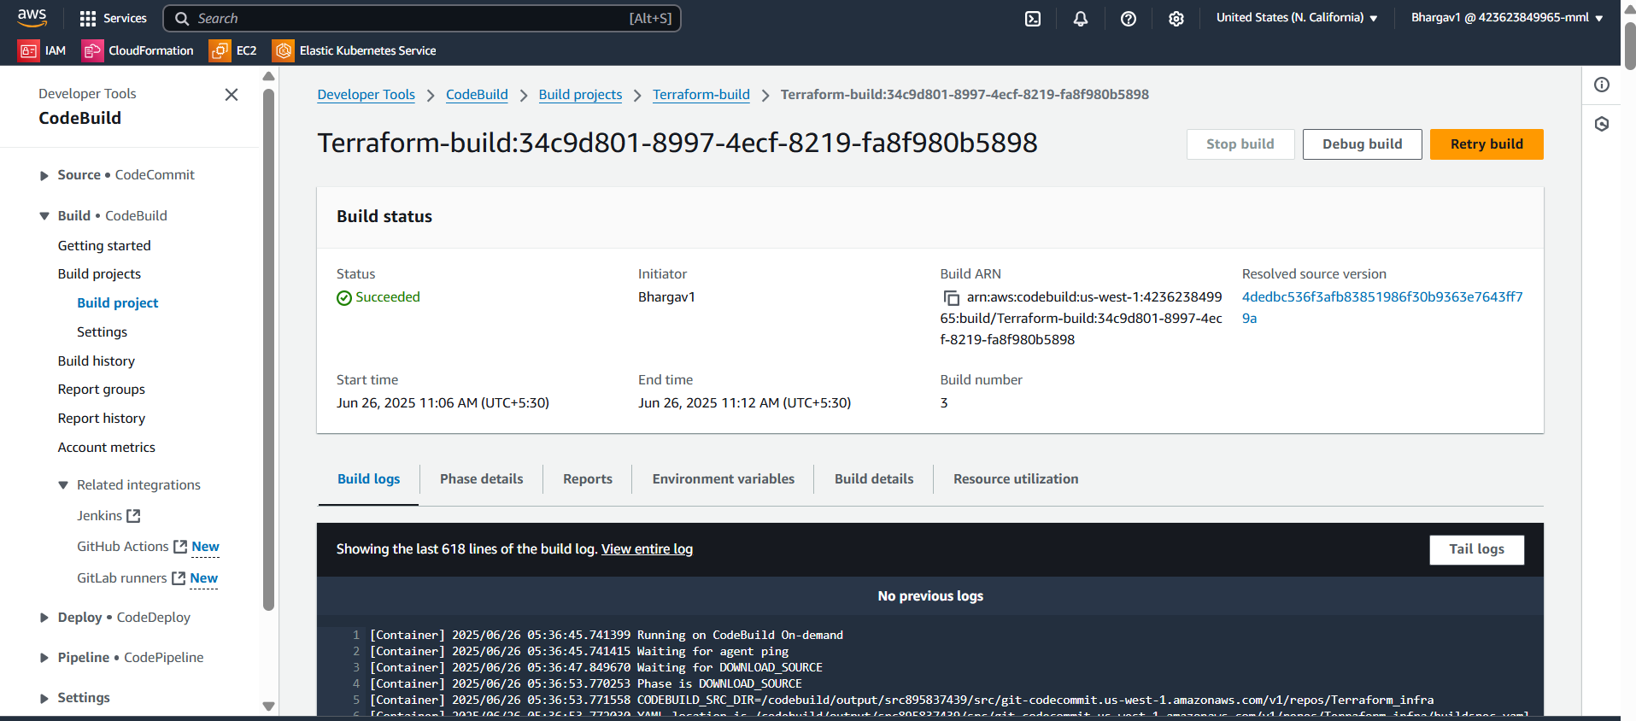

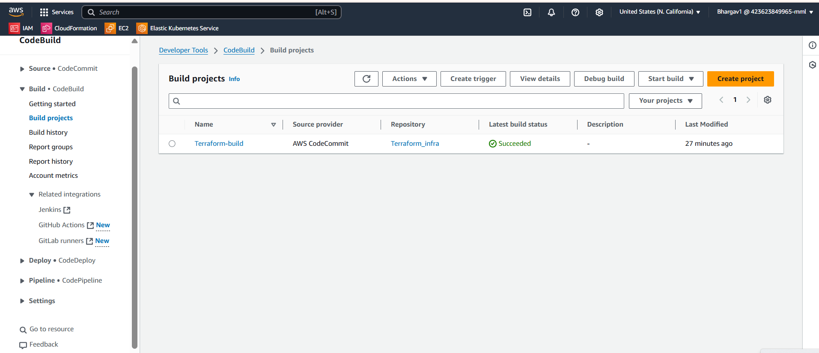

Created ECR’s

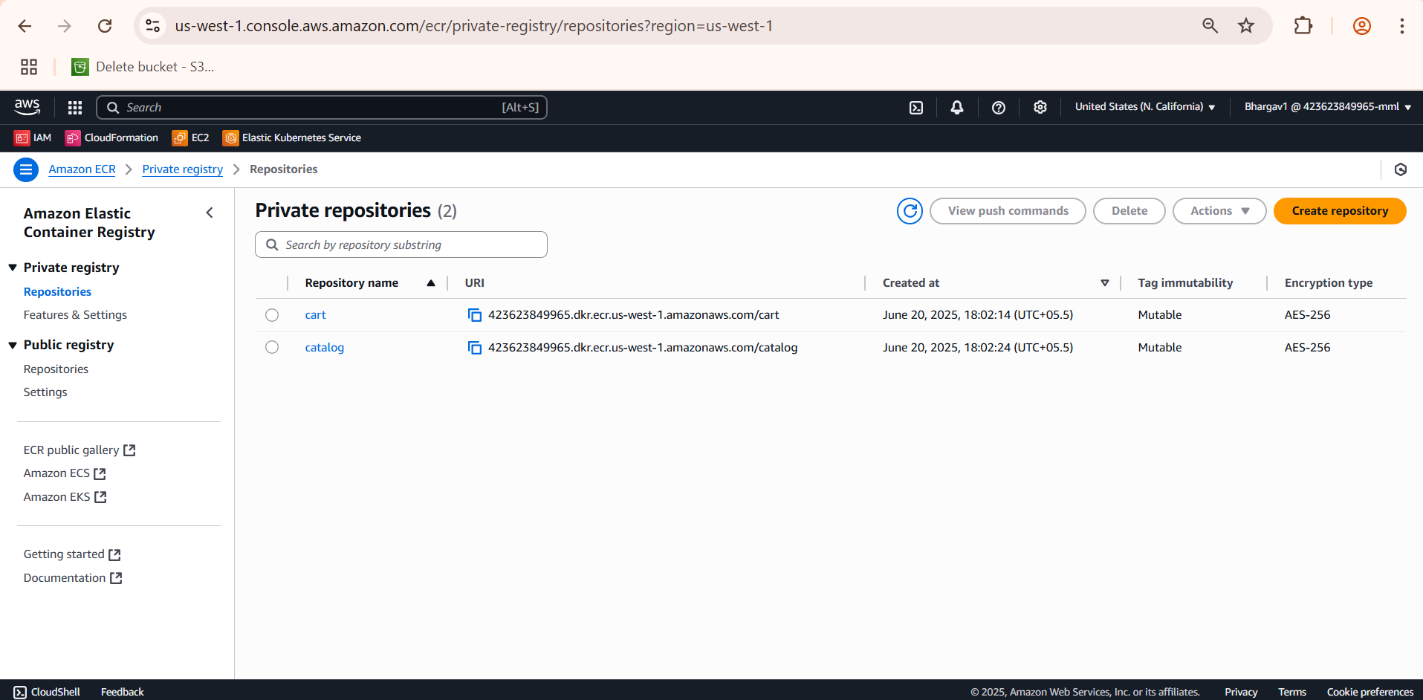

Then I have deployed my application using CodePipeline in us-west-1

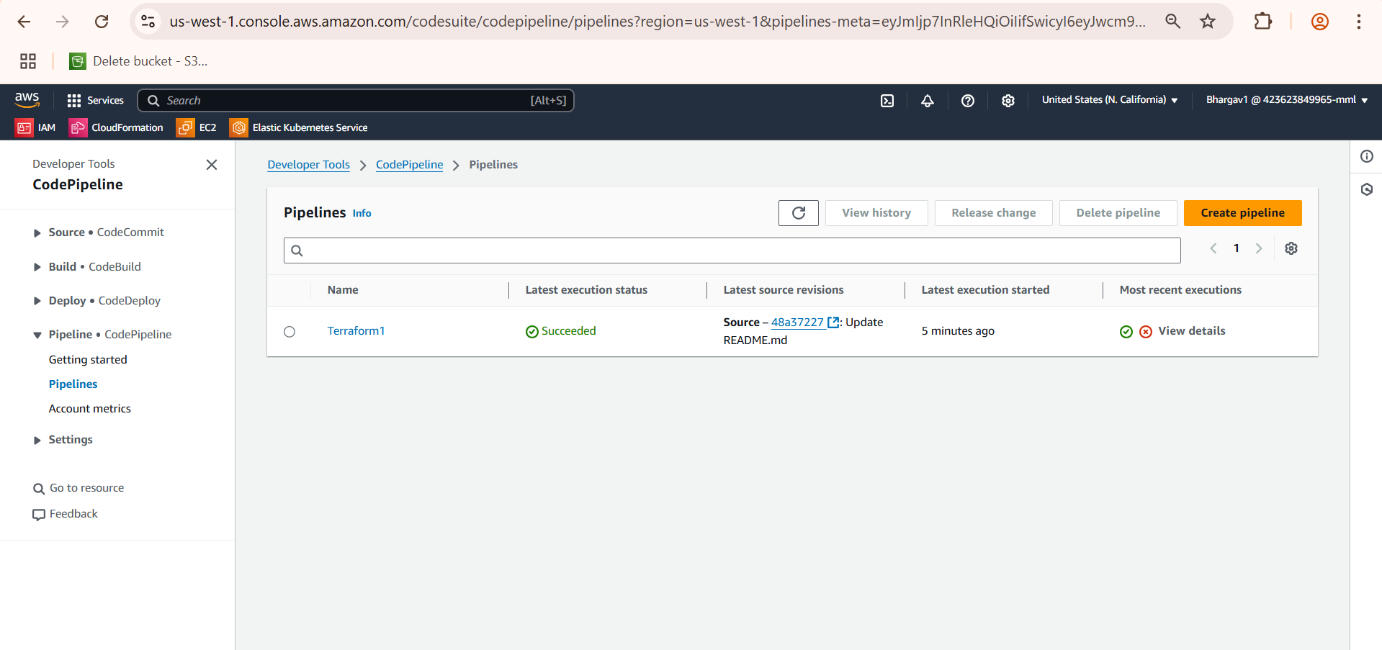

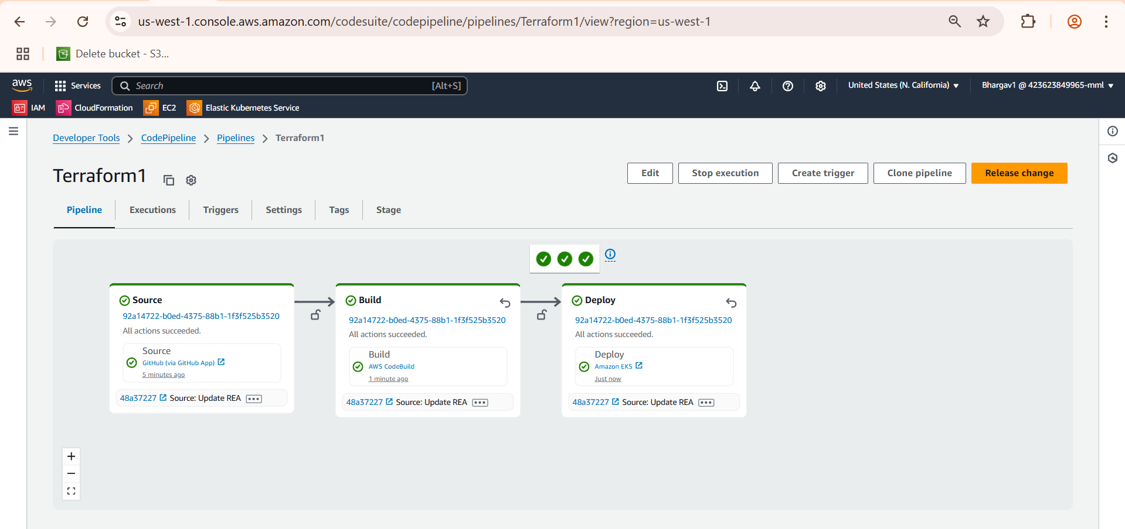

Check all pods are running or not then check service

aws eks update-kubeconfig --region us-west-1 --name ecommerce-cluster

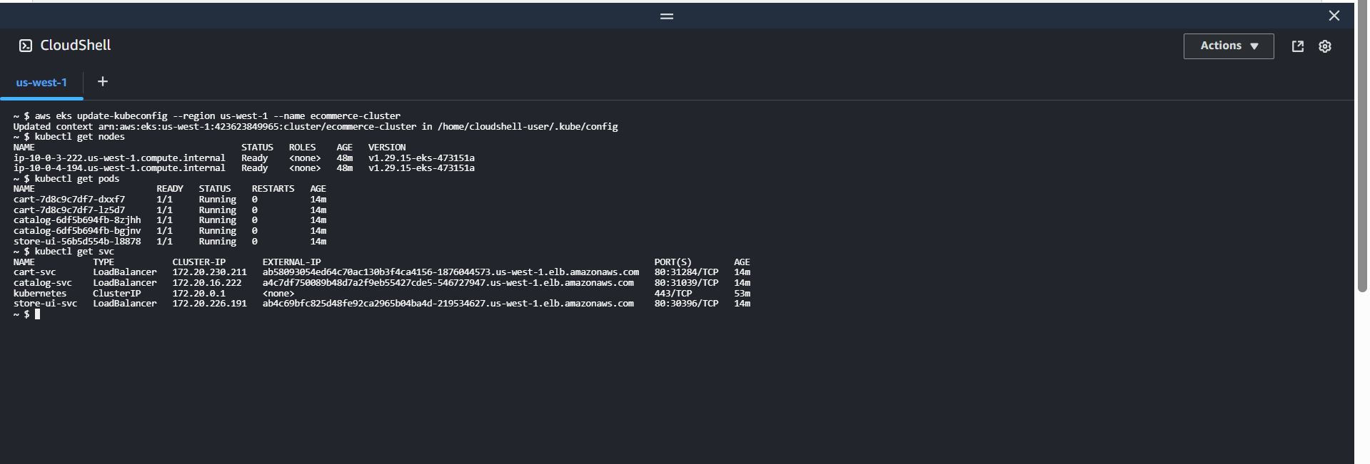

Route53

* Bought a domain bhargavkulla.com
* Set up a Route 53 health check to monitor the health of the secondary endpoint
* Created a second record
* Configured DNS Record with Failover Routing
* Then accessed the website with the domain name bhargavkulla.com
* When the primary fails (health check fails) → Route 53 automatically fails over to the secondary.

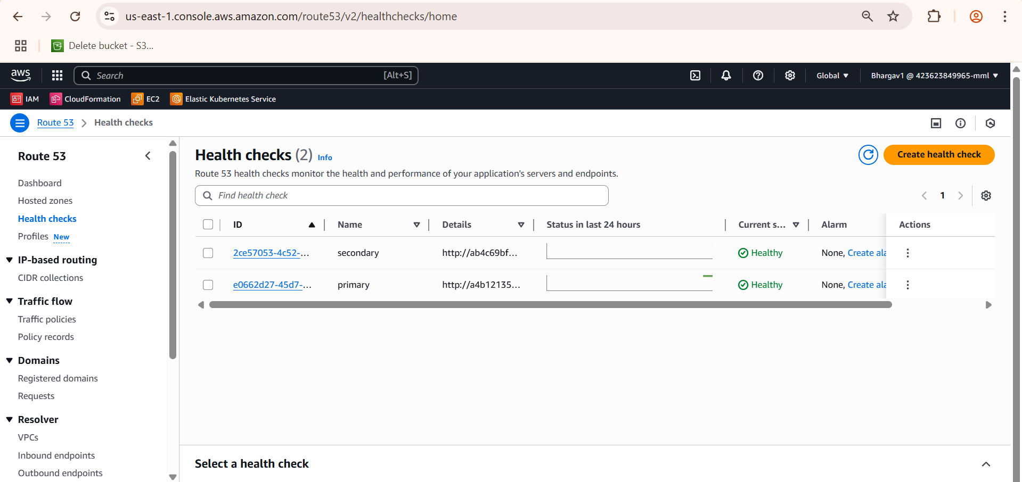

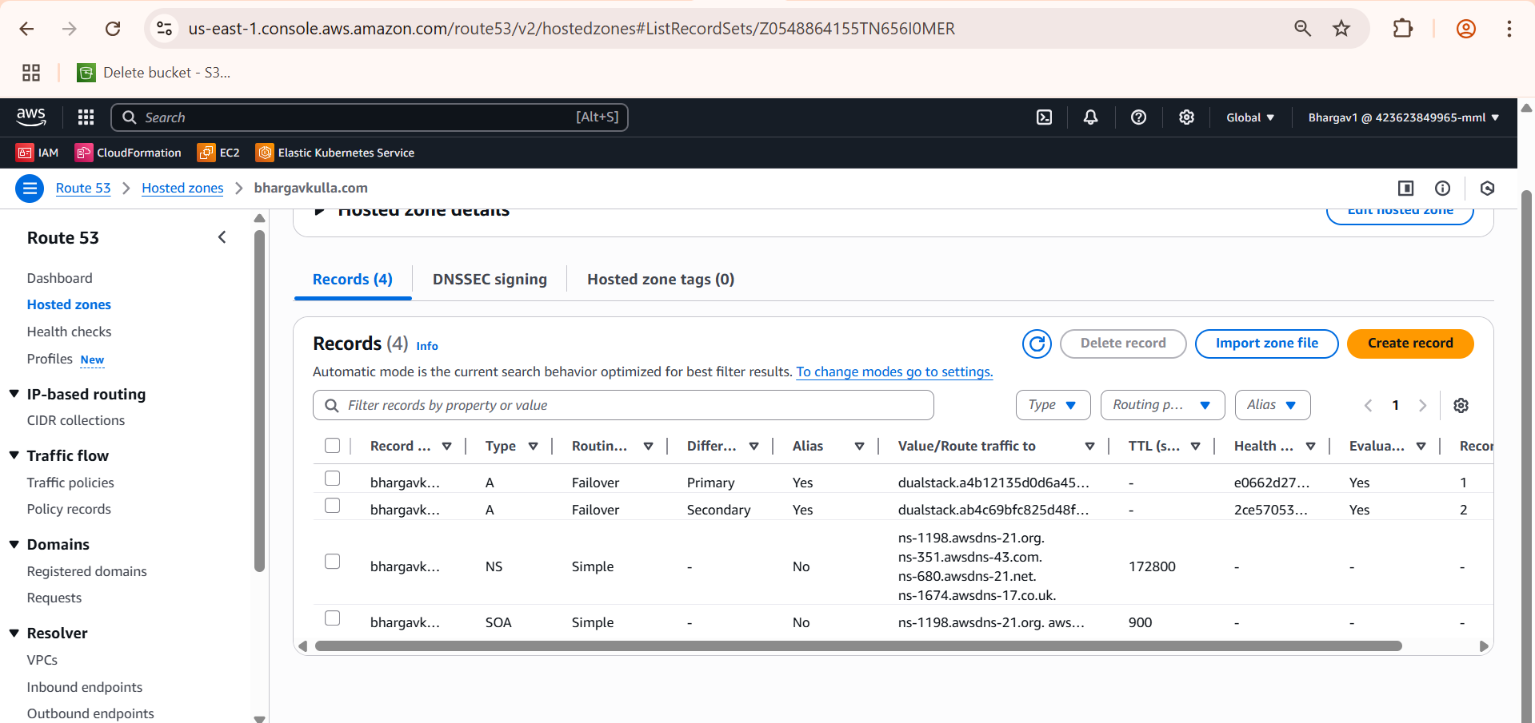



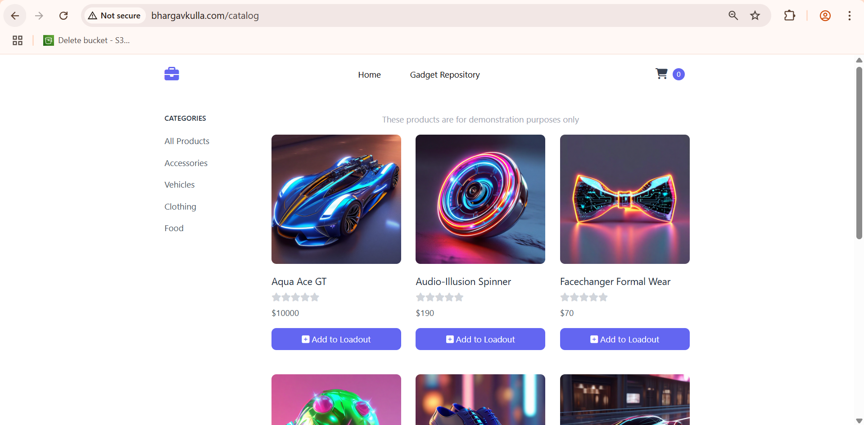

**Prometheus and Grafana**

* Deployment: I have deployed the Prometheus and Grafana components into a dedicated monitoring namespace within my EKS cluster. This includes:
* Prometheus-kube-prometheus (The Prometheus Server Itself)
* Grafana (The Grafana Server)
* Kube-state-metrics (Exposes metrics about the state of Kubernetes Objects like deployments, pods, nodes)
* Prometheus-node-exporter (Exposes host-level metrics from your EC2 instances/EKS nodes)
* AlertManager (Handles alerts generated by Prometheus rules)
* Dashboarding: I have set up various Grafana dashboards to visualize different aspects of my cluster and application performance

